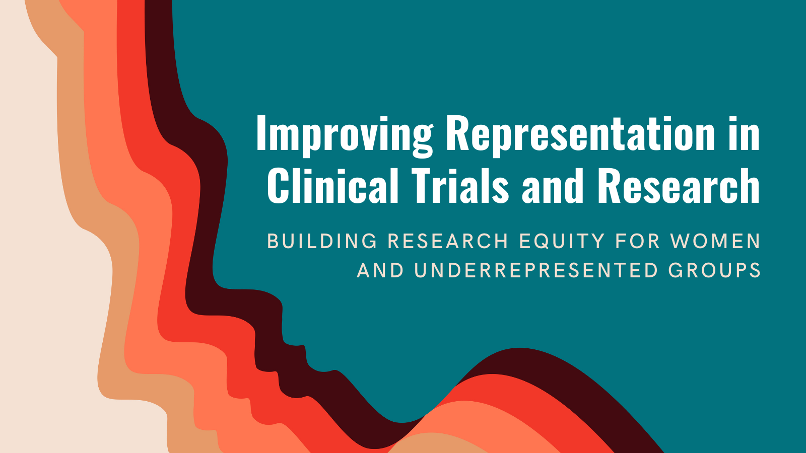
Improving Representation in Clinical Trials and Research
A Report Release Webinar
May 17, 2022
Zoom link:
Join the National Academies of Sciences, Engineering, and Medicine’s Committee on Improving the Representation of Women and Underrepresented Minorities in Clinical Trials and Research as it discusses its newly released report Improving Representation in Clinical Trials and Research: Building Research Equity for Women and Underrepresented Groups on Tuesday, May 17th, 2022.
This new report makes a compelling case for why we need more equitable participation in clinical trials and clinical research, including an economic analysis on the cost of health disparities in the United States. It provides a review of the barriers to having more equitable participation in clinical trials, describes strategies to overcome those barriers, and provides actionable recommendations to drive lasting change on this issue.

Register to Attend

